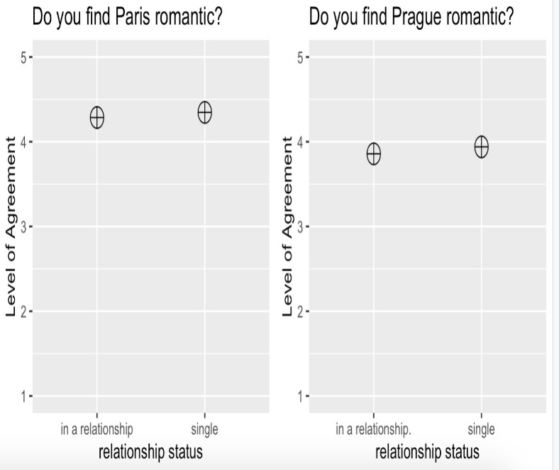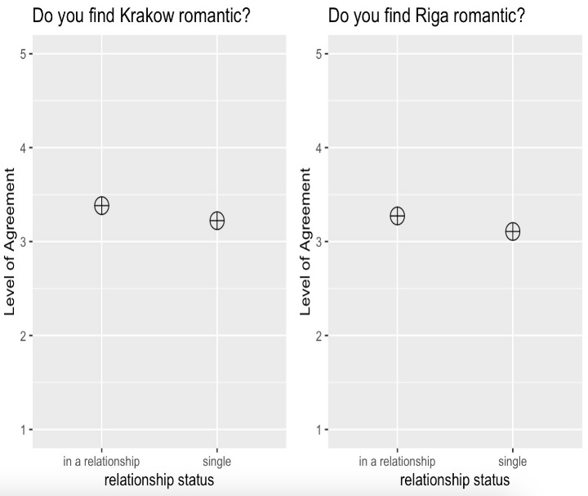

The underlying assumption behind the two graphs above is that couples might have find a particular city more romantic as they are spending time in the city together and might engage in more “romantic” activities in the city as to single people, possibly causing them to perceive it as more romantic.

What we found is that, regarding these two cities that might be perceived as more romantic than the others in the questionaire, while single people found Paris and Prague more romantic than the couples, there is no significant difference in their preferences as the difference is less than 5%.

Additionally, to eliminate the possibility that the conclusions above resulted from the nature of the cities on the left side, on the right side, we have examined Krakow and Riga as well. Contrary to the graph on left, these cities were perceived as slightly more romantic by the couples compared to singles. With more data, the difference between how the singles and couples perceives how romantic a city is could both enlargen or diminish. The data set that we had seems to indicate that there is no significant correlation between the partnership status and perceived romanticness of a particular city.

*Insight : Istanbul is more friendly than it is English-speaker friendly*



With the data we have got from 77 people about Istanbul, we have observed that the mean perceived friendliness of the city is 3.416 with a median of 4 whereas the mean perceived English-speaker friendliness is 3.091 with a median of 4. As expected, this indicates that Turkish people living in Istanbul are friendly but they don’t speak in English with foreigner for various unknown reasons.